**Version 23.1.0 for the year 2023**

­



**Table of Contents**

1. Summary 1

2. Component Overview 1

2.1 Functional Overview 1

2.2 Use Cases 1

2.2.1 Jobs 1

2.2.2 Disclaimer 1

2.3 Compatibility 1

2.4 Privacy, Payment 1

2.5 Limitations, Constraints 1

3. Implementation Guide 1

3.1 Setup 1

3.2 Configuration 2

3.2.1 Installing the cartridge(s) 2

3.2.2 Configure Coveo preferences 3

3.2.3 Configure Product Fields 5

3.2.4 Configure Coveo Service Credentials 5

3.3 Custom Code 7

4. Operations, Maintenance 8

4.1 Data Storage 8

4.2 Failure/Recovery Process 8

4.3 Support 8

5. User Guide 8

5.1 Roles, Responsibilities 8

5.2 Storefront Functionality 9

6. Known Issues/Caveats 9

7. Release History 9

# Summary

This document provides the guidelines for the implementation of the Coveo StoreFront Reference Architecture (SFRA) enabled cartridge to SalesForce Commerce Cloud (SFCC).

# Component Overview

## Functional Overview

Coveo is the cloud service that makes the intelligent search experience possible. Coveo is unparalleled at matching intent with results and thus provides the most relevant content to each user.

## Use Cases

## Jobs

Coveo cartridge supports two optional jobs that are imported in the metadata.

* **ProductsFeedExportFull** is a job that gathers all the products within a site.
* **ProductsFeedExportDelta** is a job that will gather all products after the date of the last product feed job for a site.

## Disclaimer

To establish group products and generate swatches on the Coveo search page, an alternative to utilizing the color attribute involves employing a slicing attribute. This slicing attribute is employed to categorize products for the purpose of forming swatches on the Coveo search interface. Only a single attribute can be utilized at a time for the purpose of grouping products and generating swatches on the Coveo search page.

## Compatibility

Compatibility mode: 22.7 and SFRA version is 6.2.0

## Privacy, Payment

There are currently no privacy or payment issues.

## Limitations, Constraints

There are no known limitations or constraints.

# Implementation Guide

## Setup

The following Coveo Integration tasks are included within the LINK Cartridge:

1. Installation of the cartridge
2. Import custom metadata
3. Set the newly-created metadata values (Site Preferences)
4. Import or create Product job(s)
5. Make storefront cartridge edits

## Configuration

## Installing the cartridge(s)

* **Import the int_coveo_sfra cartridge into the Commerce Cloud Studio Workspace:**

Open Commerce Cloud Studio

Click File -> Import -> General -> Existing Projects Into Workspace

Browse to the “int_coveo_sfra” directory

Click Finish.

Click OK when prompted to link the cartridge to the sandbox

* **Assign cartridge to Business Manager**

Log into Business Manager

Click Administration -> Sites -> Manage Sites -> Business Manager Site

Select the “Settings” tab

Add “bm_ coveo” and “int_ coveo” to the beginning of the cartridge path.

Click Apply

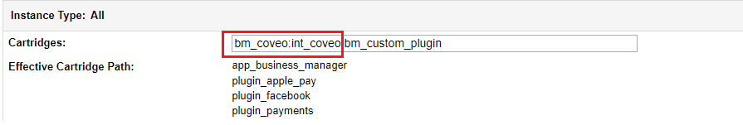

* **Assign cartridge to site**  
  Log into Business Manager  
  Click Administration -> Sites -> Manage Sites -> RefArch or the required site  
  Select the “Settings” tab  
  Add “int_coveo_sfra” , “int_ coveo _sfra_changes” “bm_coveo” and “int_ coveo” to the beginning of the cartridge path (or ensure it is in front of app_storefront_base  
  Click Apply

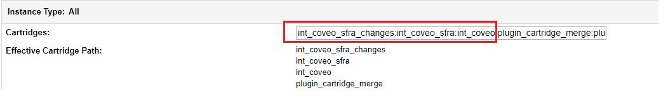

* Re-activate the current code version (on sandboxes). This may be necessary to ensure the custom job steps are available. Click [Administration](https://dev01-na01-luxurybrandholdings.demandware.net/on/demandware.store/Sites-Site/default/ViewApplication-ExpandMenuGroup?MenuGroupID=AdministrationMenu&OverviewPage=SiteNavigationBar-ShowAdministrationOverview&csrf_token=gV0CPCPqzbUWM_Y7xLVOkzpmo1l3wBw25A_Jz3QemO2H3jn8SJgyYhC_-ULx9nuKFeGuted4OXcL_RAmnAplrdfg2nnyEvQR6hx-Elu8uxJwk064aB-RYaggWSSrZDjOvpBYk7RSPYGp-EOqraLoaTVAZM5p7KUjiIV0JHwNeYZL4l_iaRw) > [Site Development](https://dev01-na01-luxurybrandholdings.demandware.net/on/demandware.store/Sites-Site/default/SiteNavigationBar-ShowMenuitemOverview?CurrentMenuItemId=studio&csrf_token=gV0CPCPqzbUWM_Y7xLVOkzpmo1l3wBw25A_Jz3QemO2H3jn8SJgyYhC_-ULx9nuKFeGuted4OXcL_RAmnAplrdfg2nnyEvQR6hx-Elu8uxJwk064aB-RYaggWSSrZDjOvpBYk7RSPYGp-EOqraLoaTVAZM5p7KUjiIV0JHwNeYZL4l_iaRw) > Code Deployment Activate a different code version from the currentActivate desired code version.

## Configure Coveo preferences

In Business Manager, navigate to the target Site > Site Preferences > Custom Preferences.

A custom site preference group with the ID **Coveo Configs** is available. Please select it and edit the attributes accordingly.

|  |  |
| --- | --- |
| **Preference Name** | **Description** |
|  |  |
| Coveo Enabled | Toggle on/off Coveo integration |
| Coveo Search Enabled | Coveo Search Enabled (it will override the default search) |
| Coveo Chunk Mode Enabled | Coveo Chunk Mode Enabled (enable this to flow to let steams work with chunk mode. Only enable it when you have large number of products) |
| Coveo Api Key | Coveo Api Key for product feeds |
| Coveo Search Api Key | Api key for coveo search |
| Coveo Organization Id | Coveo Organization Id |
| Coveo Source ID | Coveo Source ID (it will use to sync the catalog) |
| Coveo Atomic CSS URL | Coveo Atomic Library CSS URL |
| Coveo Atomic JS URL | Coveo Atomic Library JS URL |
| Coveo Catalog Last Sync | Specifies the date from which we need the products in the job |
| Coveo Search Response Fields | Add newly created fields in search response |
| Coveo Search Hub | Specifies the coveo search hub |

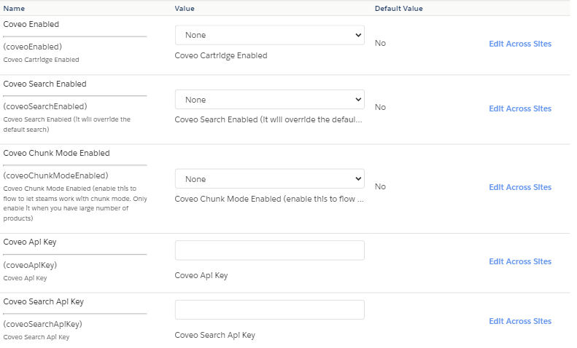

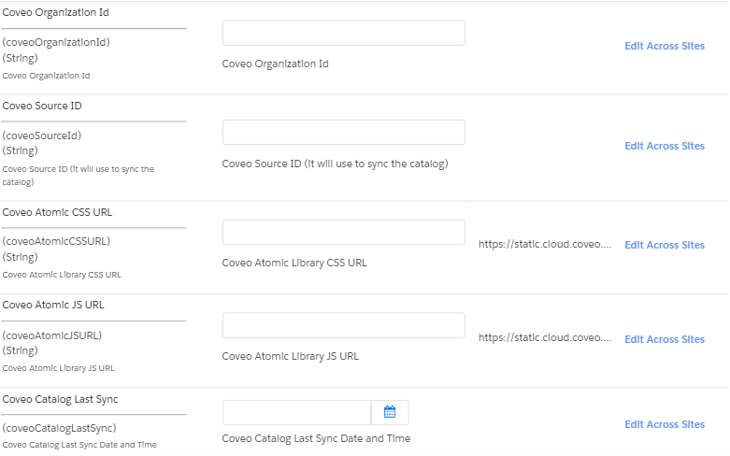

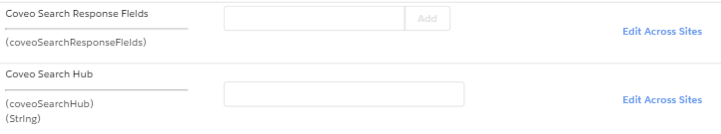

## Configure Product Fields

Since Coveo can support a large set of attributes therefore we need to create a field mapper inside our int_coveo/cartridge/scripts/utils/coveoConstant.js file which will be the following format, having key as a SFCC attribute key and value as a coveo field:

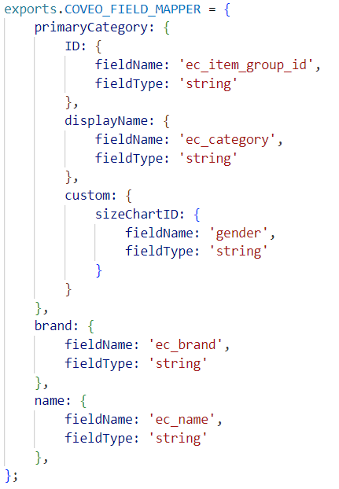

Here “brand ”is the sfcc attribute id and “ec_brand” is the coveo field which will be mapped in the coveo dashboard.

The data types allowed for these attributes are following as below.

* String
* Integer
* Decimal
* Date
* Vector

## Configure Coveo Service Credentials

Importing the services.xml metadata file will create many Coveo services, profiles, and credentials. Verify that the following exists.

**Services**

Normally these service definitions do not need to be modified.

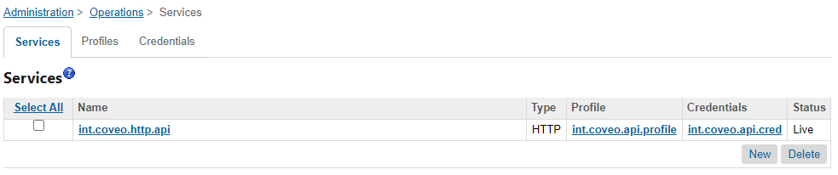

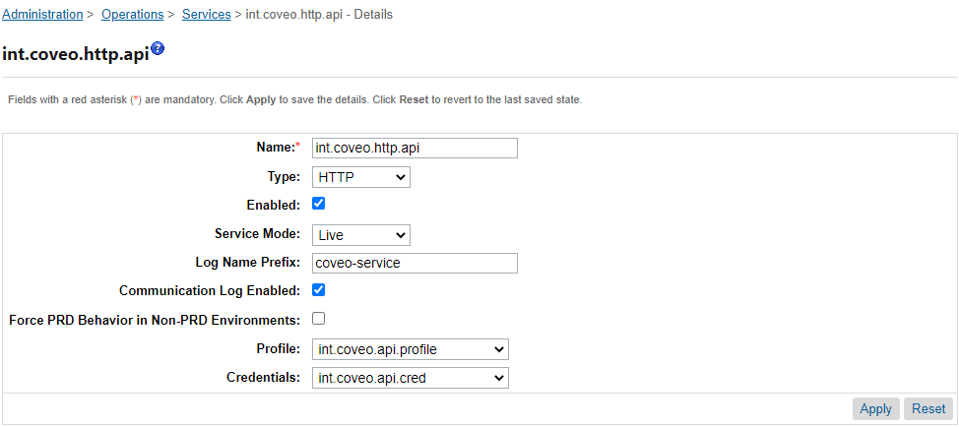

**Profiles**

Normally this profile definition does not need to be modified.

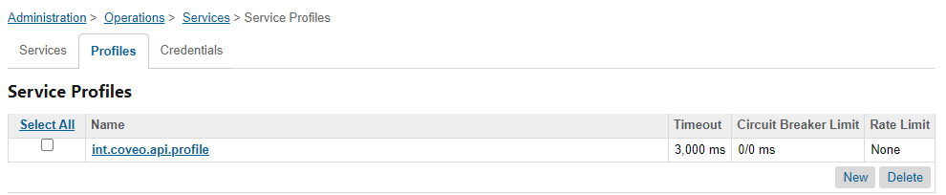

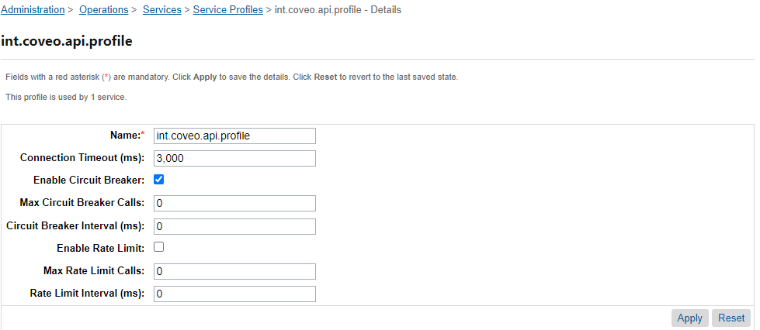

**Service Credentials**

Coveo service credentials, found in Administration > Operations > Services > Service Credentials, should be updated with the information provided by your Coveo representative.

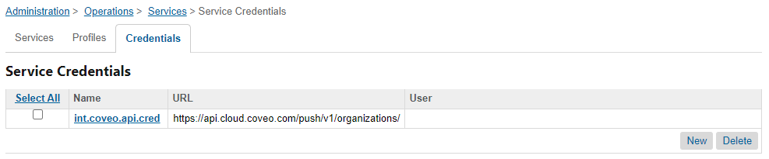

## Custom Code

The “int_coveo_sfra_changes” cartridge includes a template for coveo search. These will work with a default SFRA installation but may need to be merged into your cartridge(s) if you’ve customized the same templates.

* + 1. Please see int_coveo_sfra_changes/cartridge/templates/default/common/htmlHead.isml example template. And override the sniped code into your overridden app_storefront_base cartridge’s htmlHead.isml template.  
         
       
    2. Please see int_coveo_sfra_changes/cartridge/templates/default/components/header/pageHeader.isml example template. And override the sniped code into your overridden app_storefront_base cartridge’s pageHeader.isml template.  
         
       
    3. Please see int_coveo_sfra_changes/cartridge/templates/default/components/header/search.isml example template. And override the sniped code into your overridden app_storefront_base cartridge’s search.isml template.



* + 1. Please see int_coveo_sfra_changes/cartridge/templates/default/ search/suggestions.isml example template. And override the sniped code into your overridden app_storefront_base cartridge’s suggestions.isml template.

 

# Operations, Maintenance

## Data Storage

**Site Preferences** – the SitePreferences system object has been extended to store setup and confirmation values for each B2C Commerce site.

## Failure/Recovery Process

When the cartridge is down then products will not be exported and search feature will also not work. This will not affect the storefront and the storefront will work as expected.

## Support

For support, please submit a ticket via [coveo support portal](https://www.coveo.com/en/contact)

# User Guide

## 5.1 Roles, Responsibilities

There are no recurring tasks that need to be fulfilled to get the full potential of Coveo. As long as the configuration details are correct in your Site Preferences that is all you’ll need to do.

## 5.2 Storefront Functionality

This is how the coveo search would display on Product listing page:

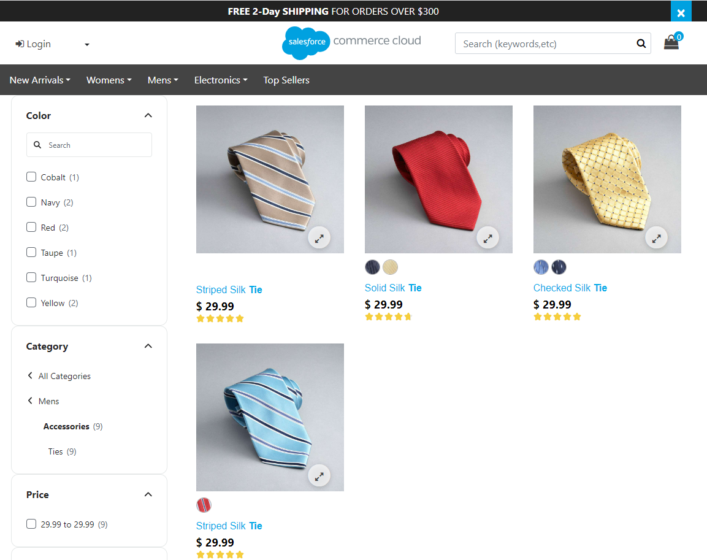

# Known Issues/Caveats

* *There are no known issues.*

# Release History

|  |  |
| --- | --- |
| **Version** | **Date** |
| 23.1.0 | 2023 |